Task1  
  
INCLUDE Irvine32.inc

.code

main PROC

;ebx is showing the series

mov eax,0

mov ebx,0

mov ecx,8

mov edx,0

call DumpRegs

mov ebx,1

call DumpRegs

L1:

mov edx,ebx

add ebx,eax

mov eax,edx

call DumpRegs

loop L1

exit

main ENDP

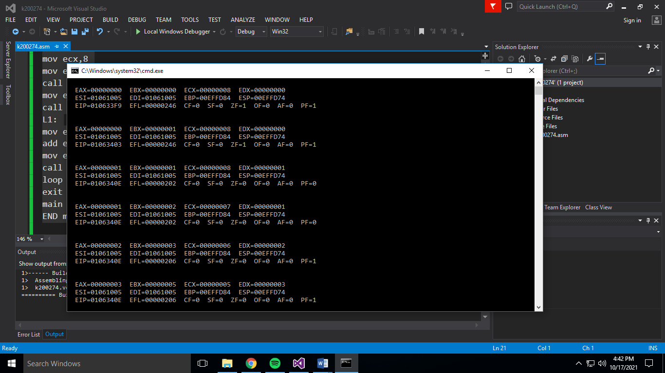

TASK 2

INCLUDE Irvine32.inc

.data

array dword 8,5,1,2,6

temp_count dword ?

temp_i dword ?

.code

main PROC

mov ecx,5

mov temp_i,0

mov temp_count,0

mov esi,0

swap:

mov array[esi],ebx

mov array[esi+4],eax

jmp back

L1:

mov temp_count,ecx

sub ecx,temp_i

dec ecx

inc temp_i

L2:

mov eax,array[esi]

mov ebx,array[esi+4]

cmp eax,ebx

JG swap

back:

add esi,4

loop L2

mov ecx,temp_count

loop L1

call DumpRegs

exit

main ENDP

END main

END main